10-5-2018

The fucking buggy stoploss

6-6-2018

included txn cost,

sig_n=seriesIncr(macd_hist) & macd_hist<0

sig_x=seriesDecr(macd_hist)

sr droppeed from 1.8 to -0.2 :0)))))))

sig_n=seriesIncr(macd_hist) & macd_hist<0

sig_x=seriesDecr(macd_hist) & macd_hist>0

sr dropped from 0.7 to 0.2

guess it is because this trade less frequently

sr of signal

1,1: seriesIncr(macd_hist) / seriesDecr(macd_hist)

1,2: ... / ...+macd_hist>0

2,1: ...+macd_hist<0 / ...

2,2: ...+macd_hist<0 / ...+macd_hist>0

For no stop loss,

1 2

[1,] 0.01849327 -0.6722346

[2,] 1.76892251 0.7474807

100% trailing stop,

1 2

[1,] -0.277920 -0.2251382

[2,] 2.262441 2.3228146

99.5% trailing stop,

1 2

[1,] -0.007114186 0.1447131

[2,] 1.116781072 1.3724036

99% trailing stop,

1 2

[1,] 0.2424293 0.5311158

[2,] 1.3170401 1.5661714

After transaction cost included, only no stop loss 2,2 has +ve sr.

99.5% trailing stop perform better then 100% trailing stop but no better than no stop loss.

After optimization, best sr is 0.3753112 in fast 32, slow 78, sig 26

7-6-2018

Took a look at

sig_n=seriesIncr(macd_hist) & macd_hist<0

sig_x=lag(macd_hist>0) & macd_hist<0

macd_hist<0 sometimes barred profitable trading opportunity

might need a longer term screen

this seems to be working, sr 2, nfast 40, nslow 74, nsig 40, ema 40, no stop

sig_n=golden_cross(macd$macd,macd$signal) & seriesIncr(ema)

sig_x=golden_cross(macd$signal,macd$macd)

8-6-2018

tried adding a ema screen, it worked, with max sr 0.0272519 !!!!

iter1, 2, 3, 4 are nFast, nSlow, nScreen, threshold

> iter1[11]

[1] 40

> iter2[10]

[1] 88

> iter3[7]

[1] 44

iter4[18]

[1] 0.997

11-6-2018

extended the optimization boundary but forgot to divide in sample period and out sample period

sr 0.03200368, win rate 0.4705882, trade 17, mean duration 3.529412

> iter1[9]

[1] 46

> iter2[5]

[1] 88

> iter3[8]

[1] 48

> iter4[9]

[1] 0.998

took a look at the graph, number of trades is way too sparse... , total return 3 %, trading 15 times, average duration 5 bar

buy too slowly, might want to go back to slope of MACD histogram

12-6-2018

changed entry signal to slope of histogram, not very effective, no of trade and duration does increase though

> max(ret_total)

[1] 0.04874208

> max(sr)

[1] 0.0167491

> max(win_rate)

[1] 0.75

>

> head(ndarray_which(ret_total,max))

dim1 dim2 dim3 dim4

[1,] 4 11 2 9

> head(ndarray_which(sr,max))

dim1 dim2 dim3 dim4

[1,] 4 11 2 9

> head(ndarray_which(win_rate,max))

dim1 dim2 dim3 dim4

[1,] 11 6 10 7

[2,] 11 4 11 7

[3,] 11 5 11 7

[4,] 10 6 11 7

[5,] 11 6 10 8

[6,] 11 4 11 8

>

added stop loss, sr dont exceed 2 still, total return dont exceed 5 %

13-6-2018

go back to

sig_n = seriesIncr(macd$macd-macd$signal) & macd$macd<macd$signal & seriesIncr(ema)

sig_x = seriesDecr(macd$macd-macd$signal) & macd$macd>macd$signal

separated in sample and out of sample

> max(ret_total)

[1] 0.05718549

> max(sr)

[1] 0.02666403

> max(win_rate)

[1] 0.8666667

>

> head(ndarray_which(ret_total,max))

dim1 dim2 dim3 dim4

[1,] 3 5 4 1

[2,] 3 6 4 1

> head(ndarray_which(sr,max))

dim1 dim2 dim3 dim4

[1,] 4 1 4 3

[2,] 4 2 4 3

[3,] 4 3 4 3

> head(ndarray_which(win_rate,max))

dim1 dim2 dim3 dim4

[1,] 4 1 3 1

[2,] 4 2 3 1

[3,] 4 3 3 1

[4,] 4 1 4 1

[5,] 4 2 4 1

[6,] 4 3 4 1

>

params are:

macd=MACD(Cl(security),nFast = 14,nSlow = 90,nSig = 14)

ema=EMA(Cl(security),112)

threshold=.985

note that no exit is by stop loss.

2018-06-14

SMA screen seems better

macd=MACD(Cl(security),nFast = 6,nSlow = 88,nSig = 30)

MA_screen=SMA(Cl(security),100)

sig_n=seriesIncr(macd$macd-macd$signal) & macd$macd-macd$signal<(0) & seriesIncr(ema)

sig_x=seriesDecr(macd$macd-macd$signal) & macd$macd-macd$signal>(0)

> head(ndarray_which(ret_total,max))

dim1 dim2 dim3 dim4

[1,] 7 4 1 6

> head(ndarray_which(sr,max))

dim1 dim2 dim3 dim4

[1,] 1 3 7 6

> head(ndarray_which(win_rate,max))

dim1 dim2 dim3 dim4

[1,] 1 5 7 6

[2,] 1 6 7 6

[3,] 5 1 2 7

[4,] 5 2 2 7

[5,] 5 3 2 7

[6,] 5 4 2 7

> iter1[1]

[1] 6

> iter2[3]

[1] 88

> iter3[7]

[1] 30

> iter4[6]

[1] 100

> ret_total[1,3,7,6]

[1] 0.08627057

> dur_mean[1,3,7,6]

[1] 19.47059

> count[1,3,7,6]

[1] 17

> win_rate[1,3,7,6]

[1] 0.8235294

> mdd_dur[1,3,7,6]

[1] 59

> mdd_pct[1,3,7,6]

[1] 0.01013616

out of sample

> perf$sr

[1] 0.01613191

> perf$trade

[1] 30

> perf$`win rate`

[1] 0.6

> perf$`holding period`

[1] 21.46667

2018-06-15

found out some bugs .....

the time object passed to perforamnce function is not by second but by 10 minute bar, possibly first and last bar of return is neglected...

rerun the loop with correct time object

fuckkkkkkkkkkk

later the day, found that I have already fixed that, see function.R

the rerun is very slowwwwwwwwww

progress:

nFast 14 nSlow 70 nSig 14 nScreen 112

but since there is not, the result should be the same

go back to check progress one hour or so later, found no progress :0))))) + ram usage low, so I stop la

2018-06-19

checking abnormal volume

updated clean.R, now night session opening is shifted one bar later

2018-06-20

abnormal opening volume has nothing special (seems)

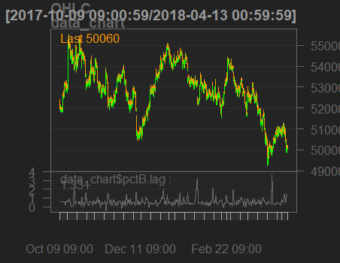

Opening volume usually high open volume, but intraday spike does occur. Might worth looking at.

E.g.

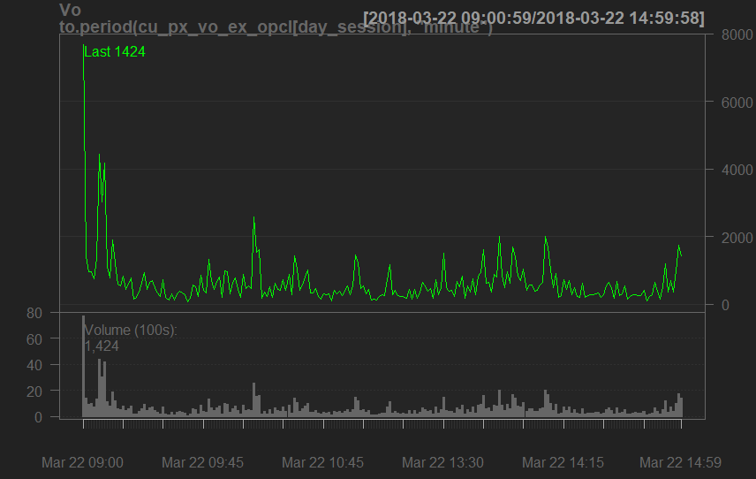

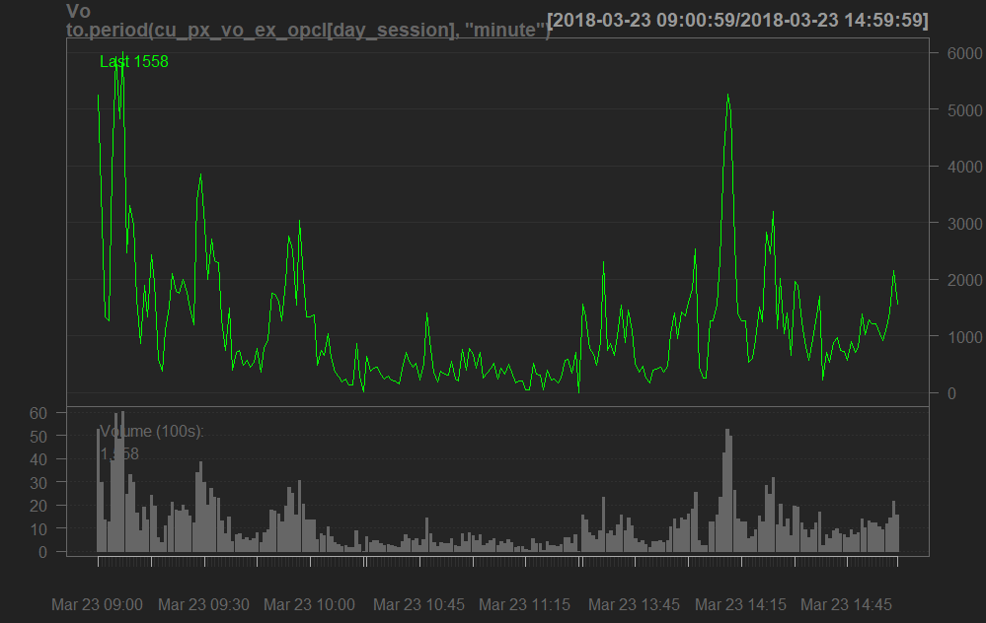

In some occasion intraday volume even greater than opening volume:

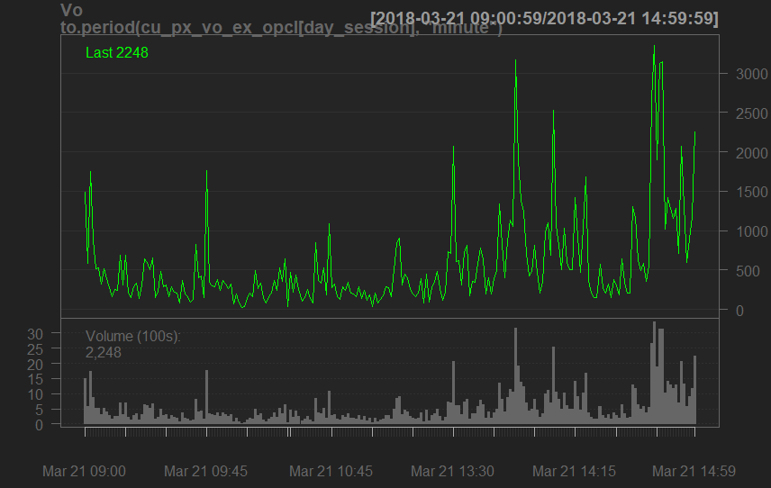

For night session,

Opening volume is not especially large, intraday spike seems to be more significant

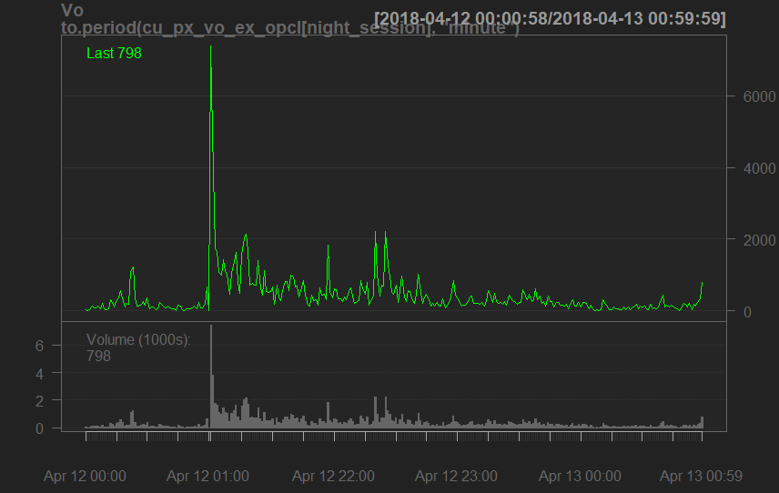

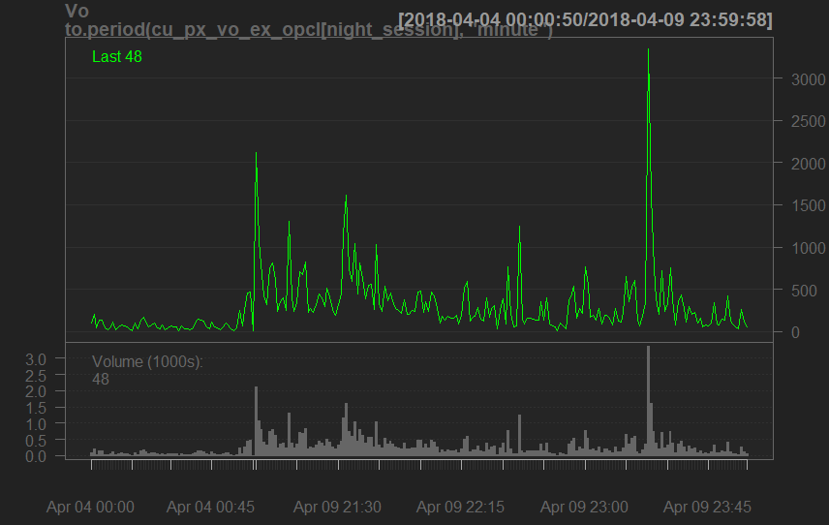

Seldom high opening volume

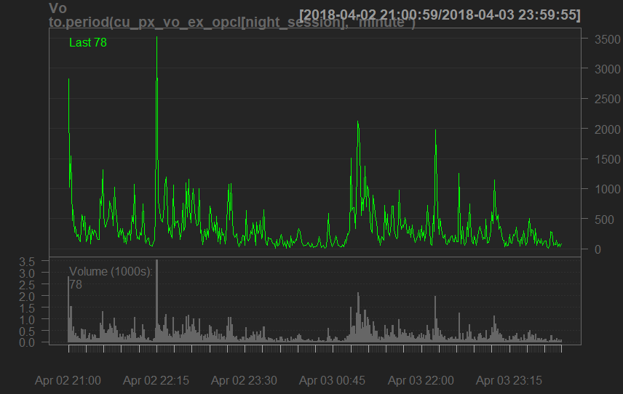

**中国大宗商品期货成交量为何连续 7 年位居世界第一？**

大前提是，中国本身早已成为了大宗商品的最大消费国，包括粗钢，精炼铜，塑料之类的基础工业品，产量远远甩开其他国家，粗钢产量甚至占到全球总产量的一半。交易所的仓单数量也巨大。这是掌握大宗商品定价权的前提，但不是必然。

从期货成交量来看，根据彭博16年的数据，中国的铁矿石期货和螺纹钢期货，平均持仓时间不足4小时。而纽约商业交易所WTI原油期货，接近40个小时；天然气期货接近70个小时。——说明国内的期货市场是投机市、散户市，流动性过剩。尽管机构投资者的比重逐步提高，但国内机构投资者也有极强的投机偏好。

中国商品期货的成交量连续多年世界第一，但是并没有相匹配的商品定价权。一是这个期货市场并未对境外投资者开放，并未使用外币结算，等于关起门来自己玩（期待即将上市的原油期货打破僵局）。二是很多农产品实施进口配额、限价、高补贴的政策，这可以理解，我们要保护本国农民的利益，保证一定的粮食自给率。三是交易时间不连续，部分品种交割规格存在厂家垄断问题。

作者：王依朦  
链接：https://www.zhihu.com/question/61287044/answer/186068429  
来源：知乎  
著作权归作者所有。商业转载请联系作者获得授权，非商业转载请注明出处。

Calvin: commodity pricing has too many factor, hard to price. Therefore, not many people dare to arb away spread between different contract months in china comdty

Change in OBV seems to be easiear to catch, less noisy

Try a Bollinger band momentum strategy on 10 second OBV copper. (later sin orz)

Lag bbands pctb is too volatile and not useful

The same for the version without lag. And the range Seems like bounded

2018-06-28

Halo im back

Tried neural net with TAs, absolute shit

TAs are names(dataframe)=c(

'adx_fast',

'adx_slow',

'aroon',

'atr_fast',

'atr_slow',

'cmf_fast',

'cmf_slow',

'cmo_fast',

'cmo_slow',

'macd',

'sar',

'roc_second',

'roc_fast',

'roc_slow',

'return'

)

Out sample prediction

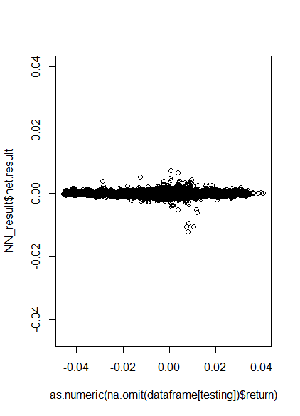

The AI is very conservative, always guess around 0

Neglect return magnitude, try to guess direction

-1 0 1

126662 4509 132205

Still shit!

2018-06-29

Use new data, purer data

dataframe=data.frame(

past_return,

past_volume,

past_volatility,

ROC(lag(SMA(Cl(security),4*60*60*20))),

log(Cl(security)/(lag(SMA(Cl(security),4*60*60*20)))),

roc

)

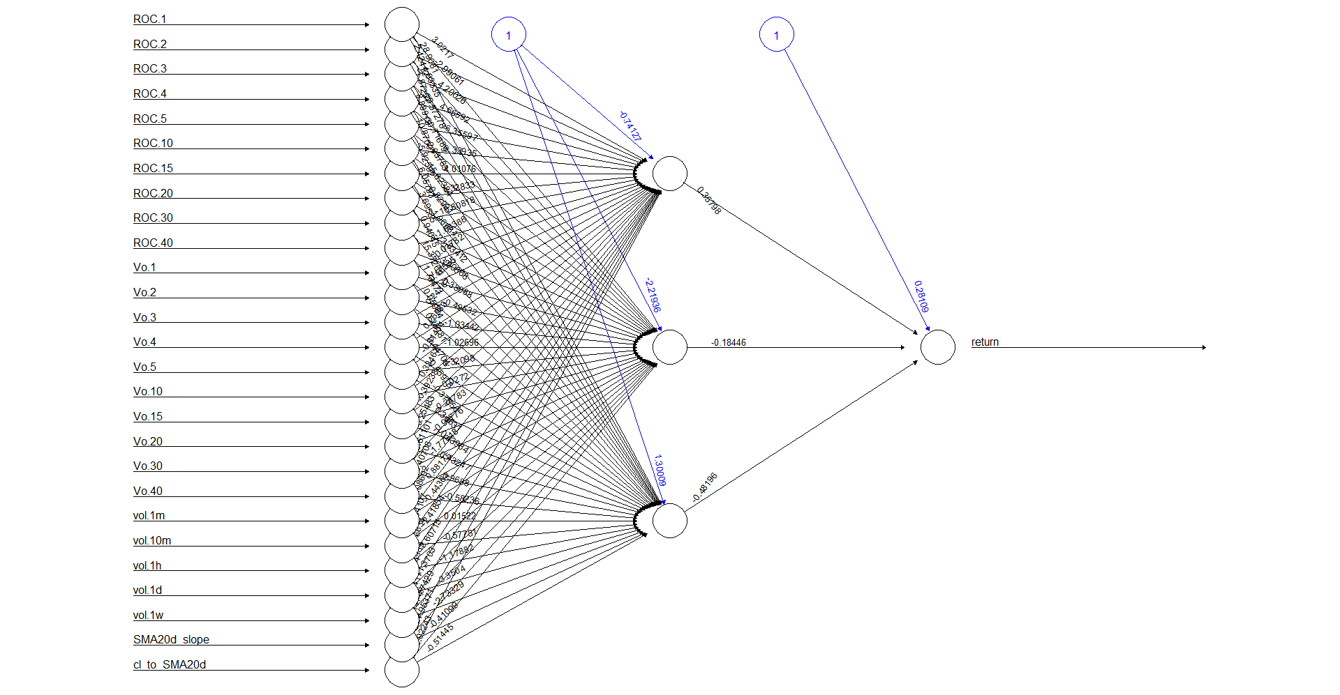

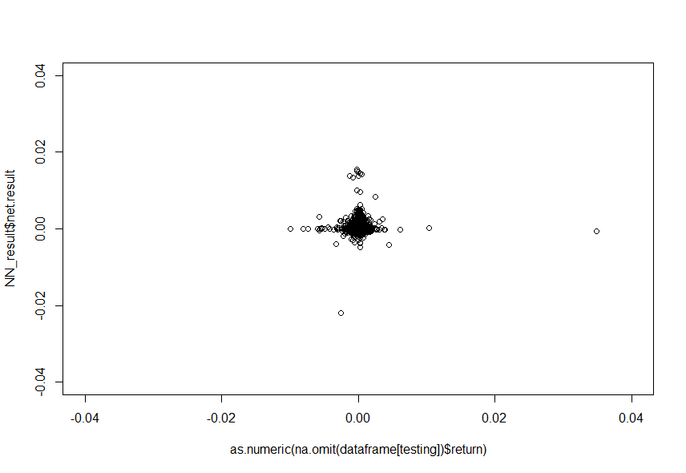

Bad at predicting magnitude, but hey, directional prediction is pretty good

-1 0 1

33723 149731 90194

Summary of positive signal generated by ai

Min. 1st Qu. Median Mean 3rd Qu. Max.

-0.00737484013 0.00000000000 0.00000000000 0.00005093005 0.00023654642 0.01030548268

Summary of positive signal generated by ai

Min. 1st Qu. Median Mean 3rd Qu. Max.

-0.00997803846 -0.00023626698 0.00000000000 -0.00006414898 0.00000000000 0.03486081723

However, holding period is too fucking short, mostly less than 5 second. Certainly cant beat transaction cost.

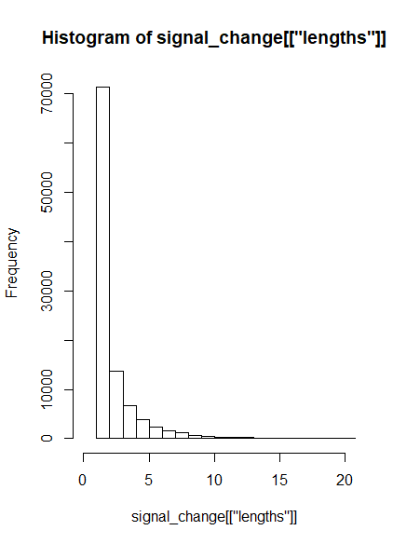

20180719

Brian suggest predict with exit time, whether the return exceed some hurdle after a period

Normalize volume with sma

Does not converge :0)